Project Proposal

On Project Title
Guided By:- Created By:-

Trainer Name: Anuj Kumar Student Name: Anuj Kumar
AFid : AF04991734

Student Name: Himanshu
AFid : AF049717773

Student Name: Rahul Prajapati
AFid :AF04991823
Batch Code: ANP-D2405
Course Code: ITPR

Table Of Contents

Index
- Title of the Project…………………………….
- Introduction……………………………………
- Objective
- Project Category
- Analysis
  - Modules and Description
  - Database Design
  - ER Diagram
  - Data Flow Diagram
- Complete Structure
  - Process Logical Diagram
- Platform Used
  - Hardware Requirement
  - Software Requirement
- Future Scope
- Bibliography

Tittle of the Project
Hospital Management System

Introduction

The Hospital Management System (HMS) is a software solution designed to digitalize and streamline the daily operations of a hospital. Instead of maintaining separate registers for patients, doctors, appointments, lab tests, and billing, the system stores all data in a centralized database.

The system mainly focuses on:
- Managing patient information and visit details.
- Managing doctors and departments with their specialization.
- Scheduling and tracking appointments between patients and doctors.
- Recording laboratory tests and results.
- Generating billing information for services availed by patients.

OBJECTIVE

To automate basic operations of a hospital using a computer-based system.

To maintain accurate and up-to-date records of patients, doctors, and departments.

To provide a proper system for booking and managing appointments.

To store and retrieve lab test details and results efficiently.

To generate bills for patients based on appointments and lab tests.

To reduce manual paperwork and chances of errors.

To allow quick searching and reporting from stored data.

PROJECT CATEGORY

- Database Management/Application Development
- Frontend: Core Java (Console/Command Line)
- Backend: MySQL Database
- Connectivity: JDBC (Java Database Connectivity).

ANALYSIS

a) Modules and Description
1. Patient Management Module
- Add new patient records (name, age, gender, phone, address, etc.).
- Update patient details if any information changes.
- Search and view patient details by Patient ID, name, or phone number.
- Maintain history of visits and tests linked to the patient.

2. Doctor & Department Management Module
- Add doctor details such as name, specialization, phone, and department.
- Maintain a master list of hospital departments
(e.g., Cardiology, Orthopedic, Neurology).
- Link each doctor to a specific department.
- View the list of doctors under each department.
3. Appointment Management Module
- Book appointments between patient and doctor.
- Record appointment date, time, and purpose.
- Check doctor availability before booking.
- Update or cancel appointments when needed.
- View all appointments for a doctor or patient.

4. Test Management Module
- Register lab tests for patients (e.g., Blood test, X-ray, MRI).
- Store test name, type, date, and results.
- Link each lab test to the corresponding patient
(and optionally to an appointment/doctor).
- Provide quick access to the patient's test history during future visits.

5. Billing Module
- Generate bills for patients based on consultation fees, lab test charges, and services.
- Store bill amount, date, and payment status (Paid/Unpaid).
- View bills patient-wise or date-wise.
- Help hospital administration maintain financial records.
6. Reports Module (Optional but Useful)
- Patient-wise report (all appointments, tests, and bills).
- Daily appointments report.
- Daily/monthly billing report.

b) Database Design
1. DEPARTMENT Table Design
Field Name | Datatype | Properties
department_id | int | primary key, auto increment
department_name | varchar(100) | not null

2. PATIENT Table Design
Field Name | Datatype | Properties
patient_id | int | primary key, auto increment
name | varchar(100) | not null
gender | varchar(10) | not null
age | int | not null
phone | varchar(15) | not null
address | varchar(200) | not null

3. DOCTOR Table Design
Field Name | Datatype | Properties
doctor_id | int | primary key, auto increment
name | varchar(100) | not null
specialization | varchar(50) | not null
phone | varchar(15) | not null
department_id | int | foreign key → department(department_id)
Relation: One patient can have multiple appointment with multiple
Doctors.

4. APPOINTMENT Table Design
Field Name | Datatype | Properties
appointment_id | int | primary key, auto increment
patient_id | int | foreign key → patient(patient_id)
doctor_id | int | foreign key → doctor(doctor_id)
appointment_date | date | not null
appointment_time | time | not null
remarks | varchar(200) | nullable

5. LAB_TEST Table Design
Field Name | Datatype | Properties
test_id | int | primary key, auto increment
patient_id | int | foreign key → patient(patient_id)
test_name | varchar(100) | not null
test_date | date | not null
result | varchar(200) | nullable
6. BILLING Table Design
Field Name | Datatype | Properties
bill_id | int | primary key, auto increment
patient_id | int | foreign key → patient(patient_id)
bill_date | date | not null
total_amount | decimal(10,2) | not null
status | varchar(20) | default 'unpaid'
Entity Relationship Diagram

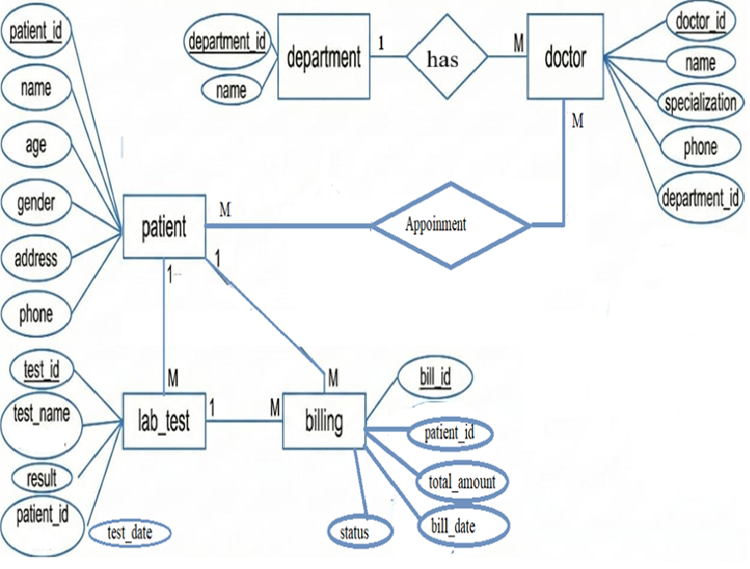

Data Flow Diagram
  - 0 Level DFD
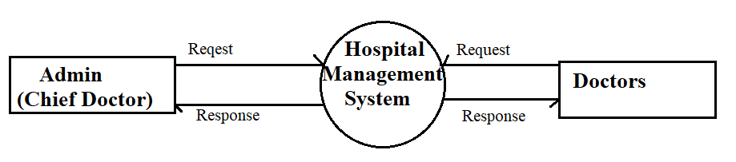
  - 1 level DFD

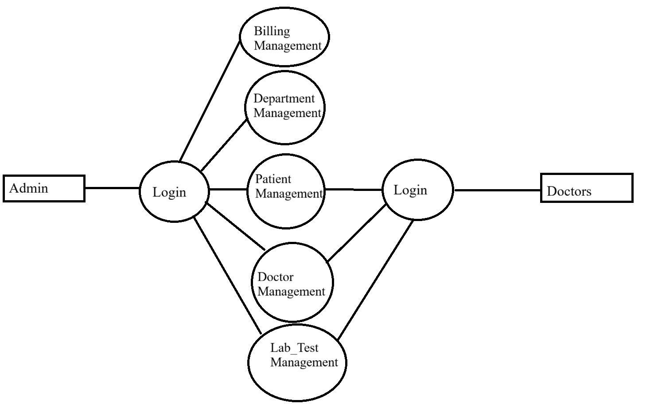

  - 2 level DFD

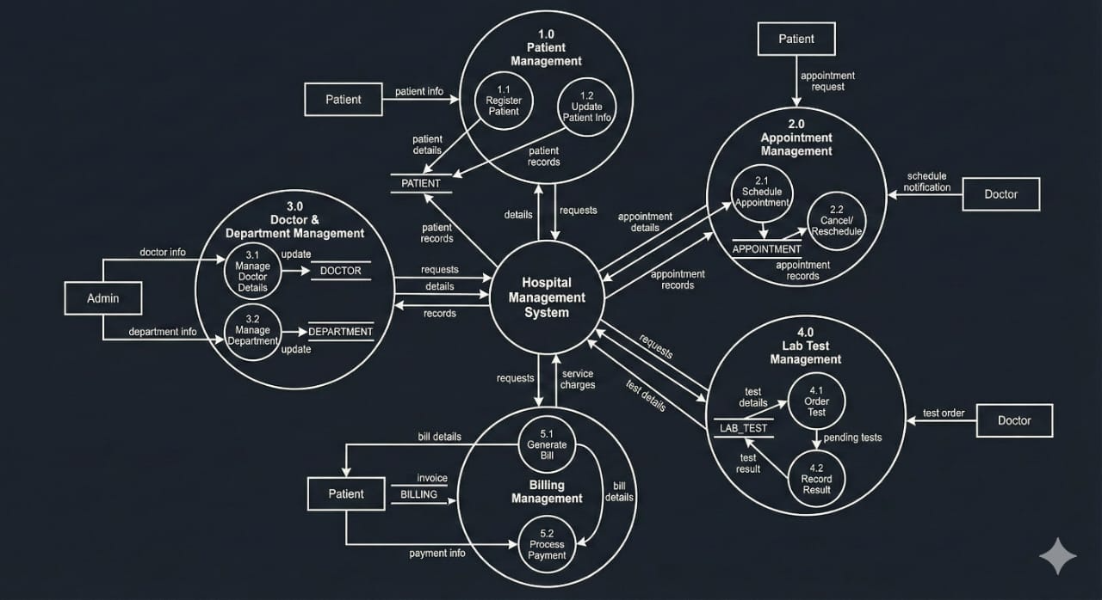

Complete Structure

Process Logic Diagram

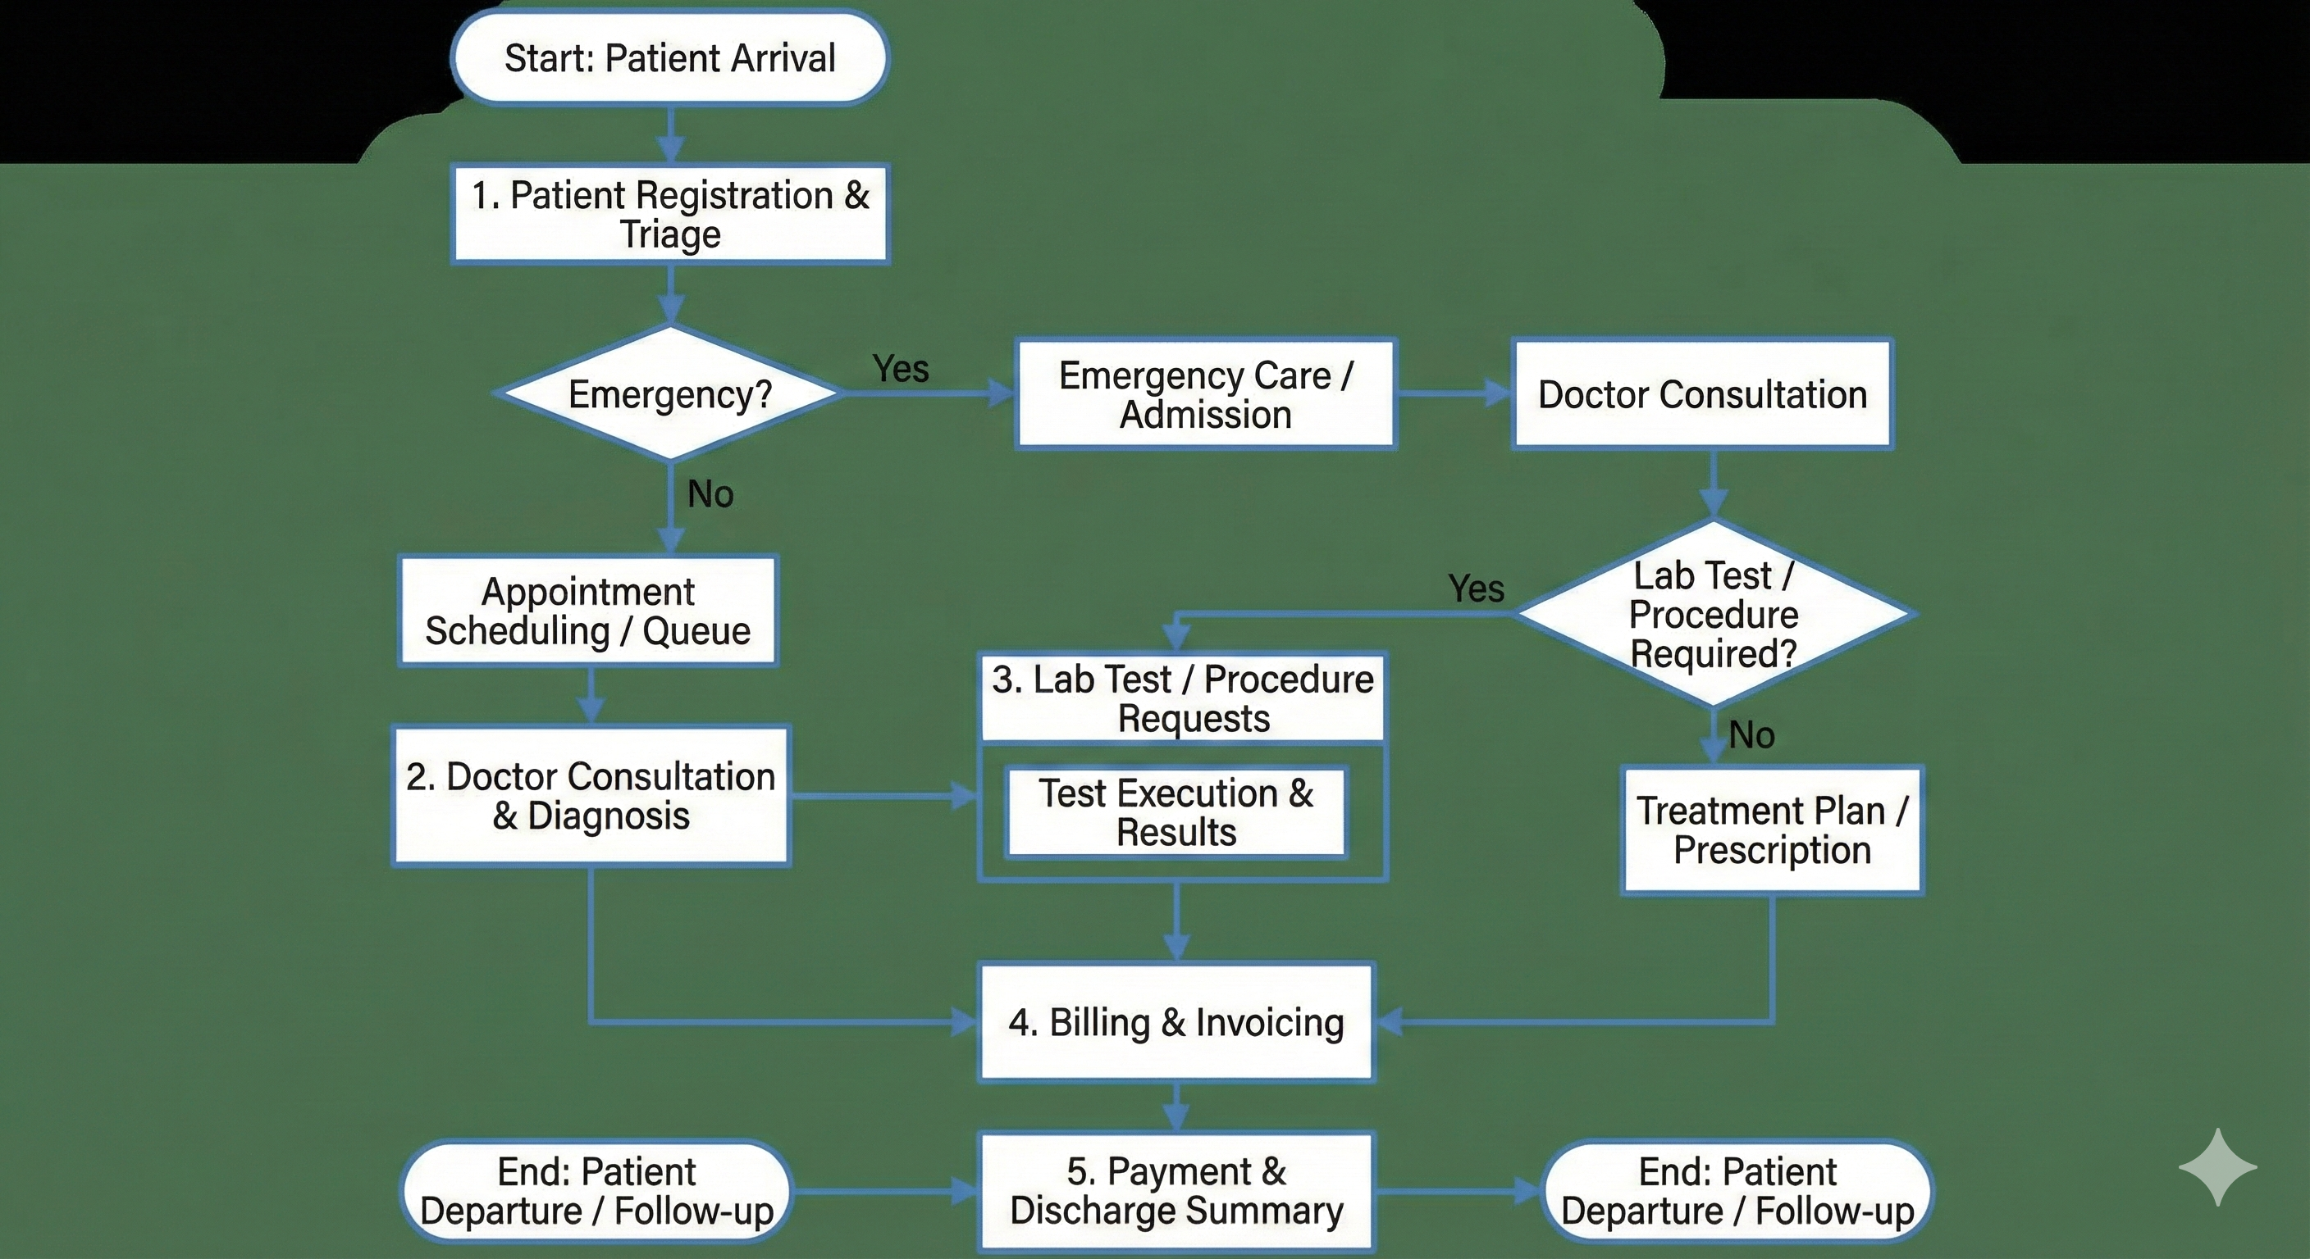

Platform Used
- Hardware Requirements: Any standard PC or laptop is sufficient. Since this is a simple command-line program, minimal specs (e.g. 1–2 GHz CPU, ~1–2 GB RAM) are adequate. It does not require specialized hardware; even a low-end machine can run the Java CLI app and MySQL server for demo purposes.
- Software Requirements:
  - Operating System: Windows, Linux, or macOS (any OS that can run Java and MySQL).
  - Java Development Kit (JDK): Java SE (version 8 or later recommended). The application is written in Java, so a JDK must be installed and configured in the system PATHgithub.com.
  - MySQL Server: MySQL Community Server (or any MySQL-compatible database) to host the hospital database. Ensure MySQL is running and accessiblegithub.com.
  - JDBC Connector: MySQL Connector/J library (JAR) added to the project so Java can connect to MySQLgithub.com.
  - IDE/Text Editor (optional): Any Java editor (e.g. Eclipse, IntelliJ, VS Code) can be used for coding; but since the app is CLI, an IDE is not strictly necessary. The GitHub example used VS Code

Future Scope
- Addition of Advanced Modules:
The system can be expanded to include Billing, Pharmacy Management, Laboratory Reports, Ward/Bed Allocation, and Staff Payroll to transform it into a complete hospital information management solution.
- Upgrade to GUI or Web Application:
The current command-line system can be redesigned with JavaFX/Swing for a graphical interface or converted into a web-based solution using Spring Boot, improving accessibility and usability.
- Integration of Online Portals:
Future enhancements may include patient and doctor portals for booking appointments, checking reports, updating medical records, and managing schedules remotely.
- Automated Notifications:
The system can be integrated with SMS/email gateways to send reminders for appointments, medicine refills, and follow-up visits, reducing patient no-shows and improving hospital workflow.
- Cloud-Based Deployment:
Deploying the system on cloud platforms can enable real-time access, automatic backups, multi-branch connectivity, and high scalability for larger healthcare networks.
- Enhanced Security:
Implementation of encryption, role-based access control, secure logins, and audit trails can strengthen data confidentiality and meet healthcare compliance standards.
- Mobile App Development:
A mobile application can be developed for doctors, staff, and patients to access the system from anywhere, improving responsiveness and convenience.

Bibliography
- Java Documentation, Oracle: Official reference for Java programming concepts, object-oriented structure, and JDBC connectivity.
- MySQL Documentation: Comprehensive guide for SQL queries, relational database design, and MySQL server configuration.
- GeeksforGeeks: Conceptual references used for understanding Hospital Management System modules, database design, ER diagrams, and Java examples.
- Tutorials Point: Learning resource for Java fundamentals, JDBC operations, and structured programming techniques.
- GitHub Community Projects.
Open-source Java–MySQL command-line project examples used for understanding modular structure and

